Prayer after Communion
Eternal God, we give you thanks for this holy mystery in which you have given yourself to us. Grant that we may go into the world in the strength of your Spirit, to give ourselves for others, in the name of Jesus Christ our Lord. Amen.
*Singing Our Faith # 220 “Angels from the Realms of Glory”
*Blessing and Dismissal
*Postlude

Scatter to Serve God & Neighbor

Welcome to all! We gather to praise God for the innumerable blessings given

to us and to grow deeper in the Spirit. Joyfully, let us lift our hearts to God.

DIRECTORY OF CHESTNUT HILL UNITED METHODIST CHURCH
Sharma Lewis | Richmond Area Resident Bishop
Denise Bates | Mountain View District Superintendent
Adam White | Minister
Erin Long | Associate Minister
Monica Campbell | Administrative Assistant
Heather Wilson | Director of Music Ministry
Judy Martin | Bookkeeper
Judy Robertson | Lay Leader

Chestnut Hill United Methodist Church
10:30 a.m. ~ December 4, 2022 ~ Second Sunday of Advent
Our ministry vision for the Virginia Annual Conference is “to be disciples of Jesus Christ who are lifelong learners, who influence others to serve.”

Welcome! Join us in worshiping God!

Prelude
Welcome and Ministry Announcements
Welcome in the name of Christ our Lord. Please register your attendance,
printing your name, address, phone, and email, on the attendance pad provided on your pew. Thank you for silencing cell phones as we gather to worship God.
Invocation
Greeting
On Jordan's bank the Baptist's cry
announces that the Lord is nigh.
Awake and harken, for he brings
glad tidings of the King of kings!

Then cleansed be every life from sin:
make straight the way for God within,
and let us all our hearts prepare
for Christ to come and enter there. (Charles Coffin, 1676-1749)
Lighting of the Advent Wreath George & Linda Jessen
Mark 1:4:
“John the baptizer appeared in the wilderness, proclaiming a baptism of repentance for the forgiveness of sins.”
We light this candle as a symbol of Christ the Way. May the Word sent from God through the prophets lead us to the way of salvation. O come, O come, Emmanuel.

*Singing Our Faith # 196 “Come, Thou Long-Expected Jesus”

*Opening Prayer
Merciful God, who sent your messengers the prophets to preach repentance and prepare the way for our salvation: Give us grace to heed their warnings and forsake our sins, that we may greet with joy the coming of Jesus Christ our Redeemer; who lives and reigns with you and the Holy Spirit, one God, now and for ever. Amen.
Greeting Friends and Neighbors
Scripture Lesson Matthew 3:1-12
The Word of God for the people of God.

Thanks be to God.
Singing Our Faith # 250 “Once in Royal David’s City”
The Good News “Turning Stones into Children”

Bringing Forward God’s Tithes and Our Gifts
*Doxology # 95 Praise God from whom all blessings flow; praise him, all
Creatures here below; praise him above, ye heavenly host; praise Father, Son, and Holy Ghost. Amen.
*Prayer of Thanksgiving
Sharing of Joys and Concerns
The Lord’s Prayer

Our Father, who art in heaven, hallowed be thy name. Thy kingdom come,
Thy will be done on earth as it is in heaven. Give us this day our daily bread and forgive us our trespasses, as we forgive those who trespass against us. And lead us not into temptation, but deliver us from evil. For thine is the kingdom, and the power, and the glory, forever. Amen.
Prayer of Consecration
Breaking Bread

**Calendar**
Monday, 12/5 | 5:00 p.m. | CSE Craft Event (Camp Meadowlark)
CITRUS Fruit Sale Drop Off
Tuesday, 12/6 thru Thursday, 12/8
See Eleanor Maxham for information.
Friday, 12/9 | 10:00 a.m. | Homeschool
 | 5:30 p.m. | Homeschool Talent Gala
**Looking Ahead on the Calendar **
Sunday, 12/11 | 11:45 a.m. | CHUMC Christmas Luncheon  Chicken and ham will be provided. Please bring one covered dish (hot or cold) and/or dessert. Sign-up forms are placed in the bulletins for what you are bringing and for what help you can provide. Place RSVP forms in the basket that is located in the Commons. Non-member guests are welcome!
Monday, 12/12 | 6:30 p.m. | Wesleyan Group @ Charley’s Restaurant
Tuesday, 12/13 | 6:30 p.m. | Choir


For the Grocery Cart:
December ~ Laundry Detergent, Dishwashing Liquid, & side items for a Christmas meal. Make sure all cans have tab tops. Place donations in the grocery cart, located in the Commons. No “baked goods” of any kind!
Christmas Offering
We have set a goal of $6,000, with 10% going to Park View Community Mission,
and 90% toward HVAC repair/replacement for social hall and educational building. Envelopes are placed in the pew racks.

“Angel Tree”
The Angel Tree is set up in the Commons. You may shop for your angel and return wrapped gifts to church NO LATER than December 18th, or you may choose to donate money and the Humankind staff will shop and wrap the gifts. BE SURE to sign the Angel Tree information sheet after selecting your angel. Checks should be made out to “Chestnut Hill UMC”, and marked for “Angel Tree”, and put in the offering plate by next Sunday, December 11th.
Advent Study
I want to invite you to consider joining me in a 4 week Advent study called “The season of waiting” by Kate Bowler available online for free at https://katebowler.com/advent2022/ ~Erin
Estimate of Giving for 2023
It is that time of year when we are all asked to take a prayerful look at our giving and to make a financial commitment for CHUMC ministries. “Estimate of Giving cards” are provided in the Commons (or use tare off from the December newsletter) for your convenience to fill out and send to CHUMC, or put it in the weekly offering plate, during December so that we have your pledge by the end of December. We plan to have a luncheon after church in February to celebrate our statement of faith to support the ministries of CHUMC. More information provided later.

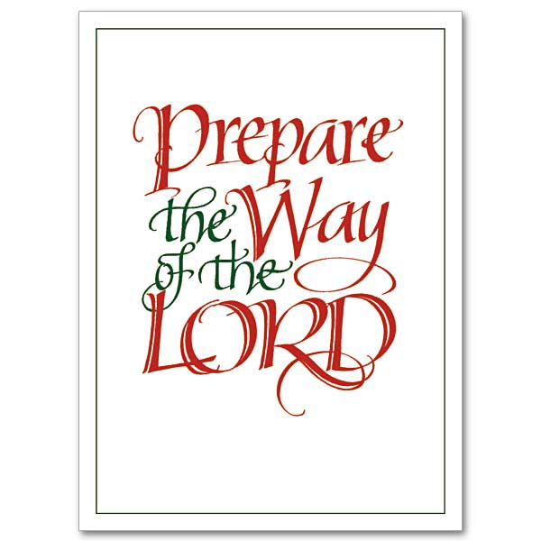

**Calendar**
Monday, 12/5 | 5:00 p.m. | CSE Craft Event (Camp Meadowlark)
CITRUS Fruit Sale Drop Off
Tuesday, 12/6 thru Thursday, 12/8
See Eleanor Maxham for information.
Friday, 12/9 | 10:00 a.m. | Homeschool
 | 5:30 p.m. | Homeschool Talent Gala
**Looking Ahead on the Calendar **
Sunday, 12/11 | 11:45 a.m. | CHUMC Christmas Luncheon  Chicken and ham will be provided. Please bring one covered dish (hot or cold) and/or dessert. Sign-up forms are placed in the bulletins for what you are bringing and for what help you can provide. Place RSVP forms in the basket that is located in the Commons. Non-member guests are welcome!
Monday, 12/12 | 6:30 p.m. | Wesleyan Group @ Charley’s Restaurant
Tuesday, 12/13 | 6:30 p.m. | Choir

For the Grocery Cart:
December ~ Laundry Detergent, Dishwashing Liquid, & side items for a Christmas meal. Make sure all cans have tab tops. Place donations in the grocery cart, located in the Commons. No “baked goods” of any kind!
Christmas Offering
We have set a goal of $6,000, with 10% going to Park View Community Mission,
and 90% toward HVAC repair/replacement for social hall and educational building. Envelopes are placed in the pew racks.

“Angel Tree”
The Angel Tree is set up in the Commons. You may shop for your angel and return wrapped gifts to church NO LATER than December 18th, or you may choose to donate money and the Humankind staff will shop and wrap the gifts. BE SURE to sign the Angel Tree information sheet after selecting your angel. Checks should be made out to “Chestnut Hill UMC”, and marked for “Angel Tree”, and put in the offering plate by next Sunday, December 11th.
Advent Study
I want to invite you to consider joining me in a 4 week Advent study called “The season of waiting” by Kate Bowler available online for free at https://katebowler.com/advent2022/ ~Erin
Estimate of Giving for 2023
It is that time of year when we are all asked to take a prayerful look at our giving and to make a financial commitment for CHUMC ministries. “Estimate of Giving cards” are provided in the Commons (or use tare off from the December newsletter) for your convenience to fill out and send to CHUMC, or put it in the weekly offering plate, during December so that we have your pledge by the end of December. We plan to have a luncheon after church in February to celebrate our statement of faith to support the ministries of CHUMC. More information provided later.


Chestnut Hill
United Methodist Church

Making disciples of Jesus Christ
for the transformation of the world.
You are welcome at Chestnut Hill UMC.

4660 Fort Avenue ~ Lynchburg, Virginia 24502
Church: 434-239-8423
Minister’s Cell: 434-944-7723, Minister’s Email: awhite@ves.org
Associate Minister’s Cell: 1-502-489-0200
Associate Minister’s Email: healingsolutions12@gmail.com
chestnuthillumc@comcast.net ~ on the web at chestnuthillumc.net
Find us on Facebook: Chestnut Hill United Methodist Church

